Cuboctahedron

Definition
# Source: AI Source: Provided by: [Data Path: Persons Table -> ID Column: 1, Name_En Column: Motasem Essam] -> From: [ChatGPT] on [7/25/2026]
A Cuboctahedron is a convex Archimedean solid composed of 8 equilateral triangular faces and 6 square faces.
It has 12 vertices and 24 edges, with two triangles and two squares meeting at every vertex in an alternating arrangement.
It is also known as the Rectified Cube or Rectified Octahedron, because it can be constructed by cutting the vertices of a cube or octahedron at the midpoints of their edges.

Geometric Structure
# Source: AI Source: Provided by: [Data Path: Persons Table -> ID Column: 1, Name_En Column: Motasem Essam] -> From: [ChatGPT] on [7/25/2026]
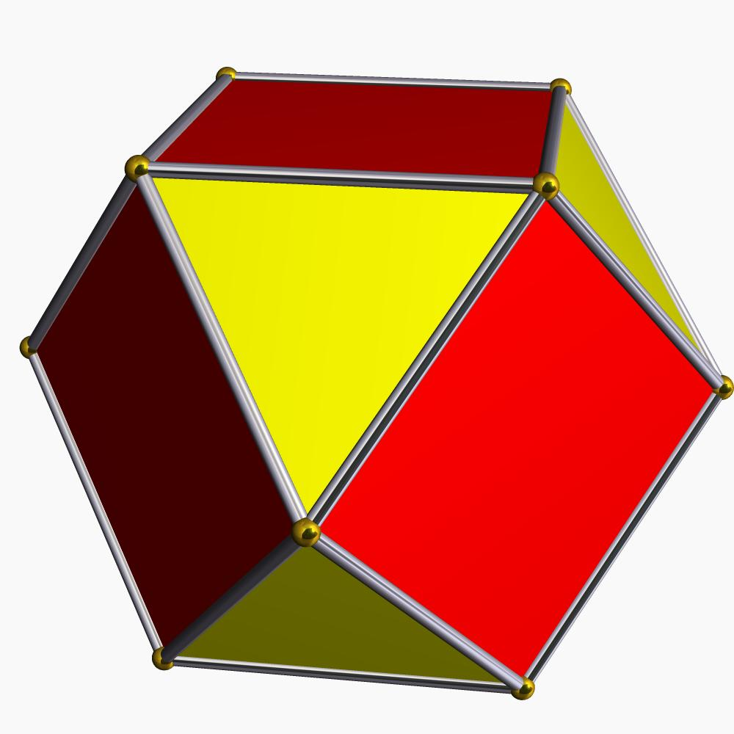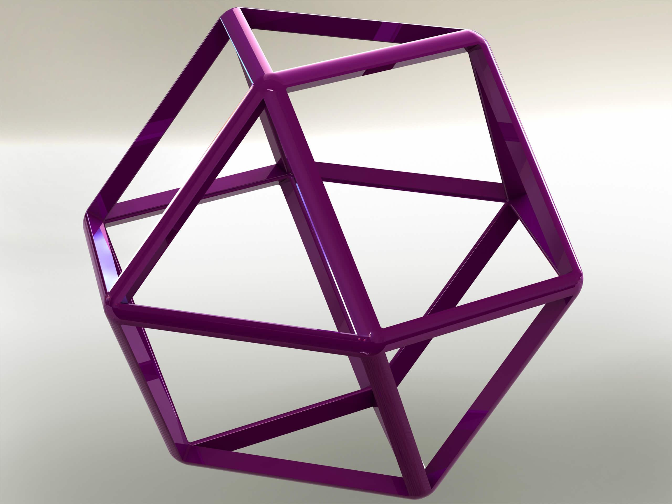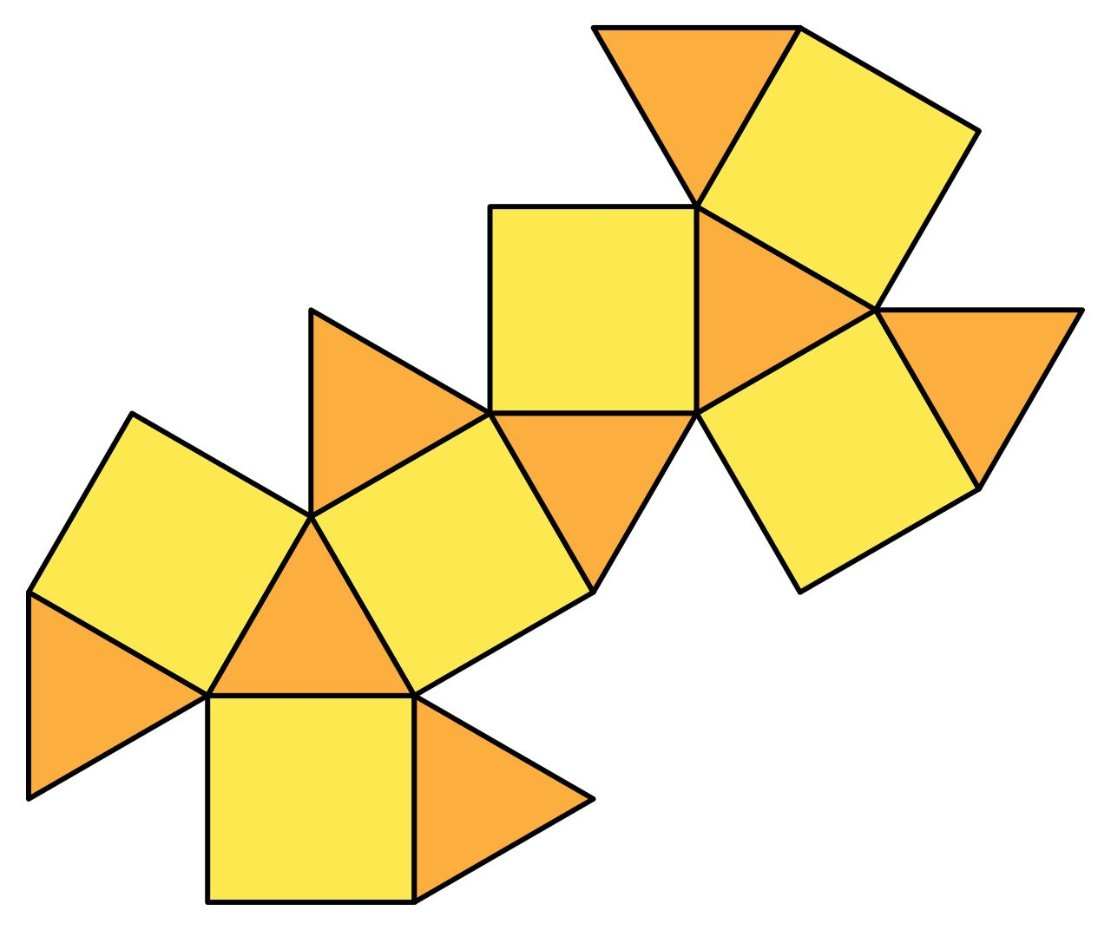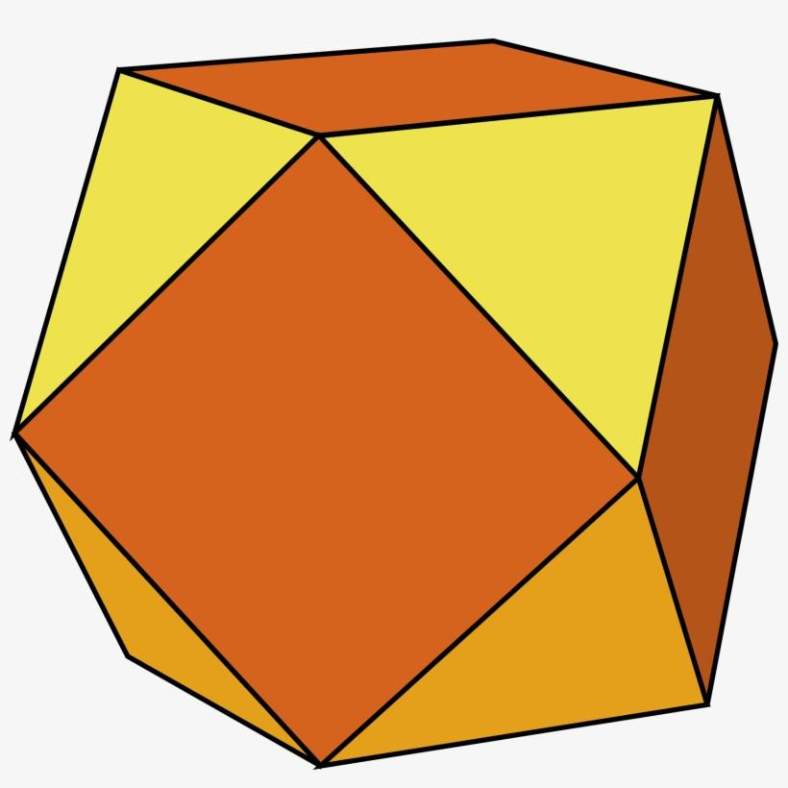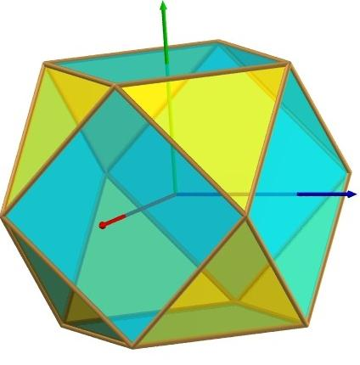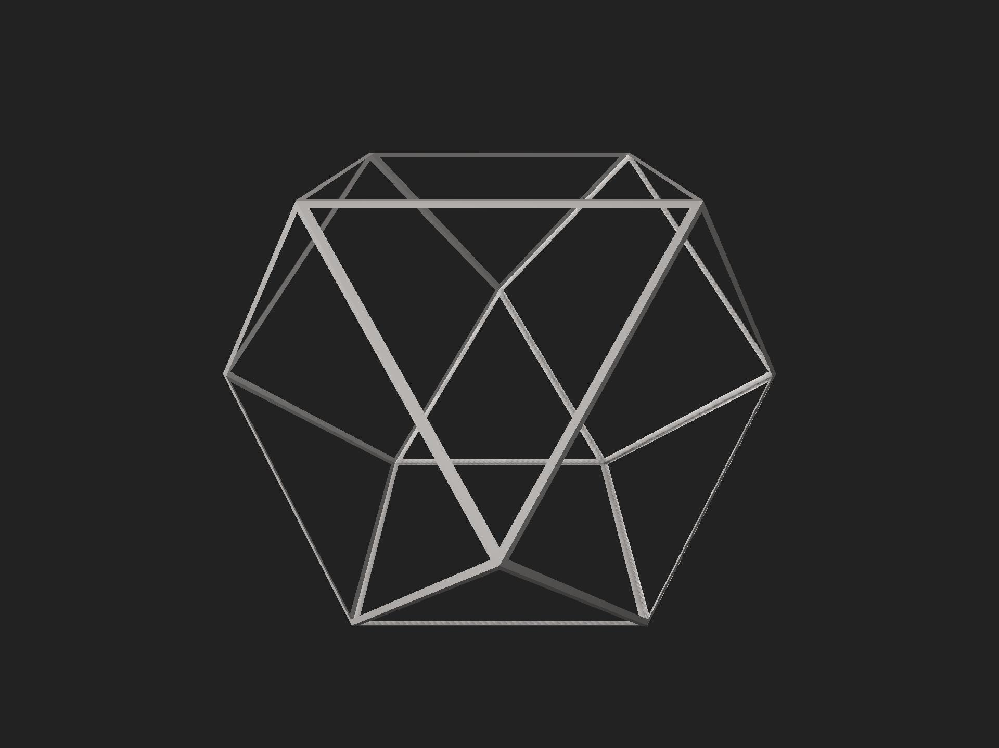
The Cuboctahedron has the following structural elements:
- Triangular Faces: 8 equilateral triangles.
- Square Faces: 6 squares.
- Vertices: 12 vertices, each shared by two triangular faces and two square faces.
- Edges: 24 edges, each connecting a triangular face to a square face.
- Central Structure: The solid is arranged symmetrically around its center.

Face Composition
# Source: AI Source: Provided by: [Data Path: Persons Table -> ID Column: 1, Name_En Column: Motasem Essam] -> From: [ChatGPT] on [7/25/2026]
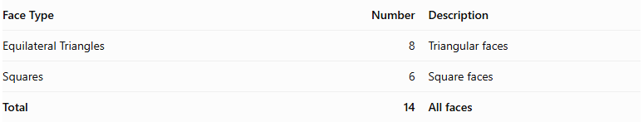
Face Type | Number | Description
Equilateral Triangles | 8 | Triangular faces
Squares | 6 | Square faces
Total | 14 | All faces
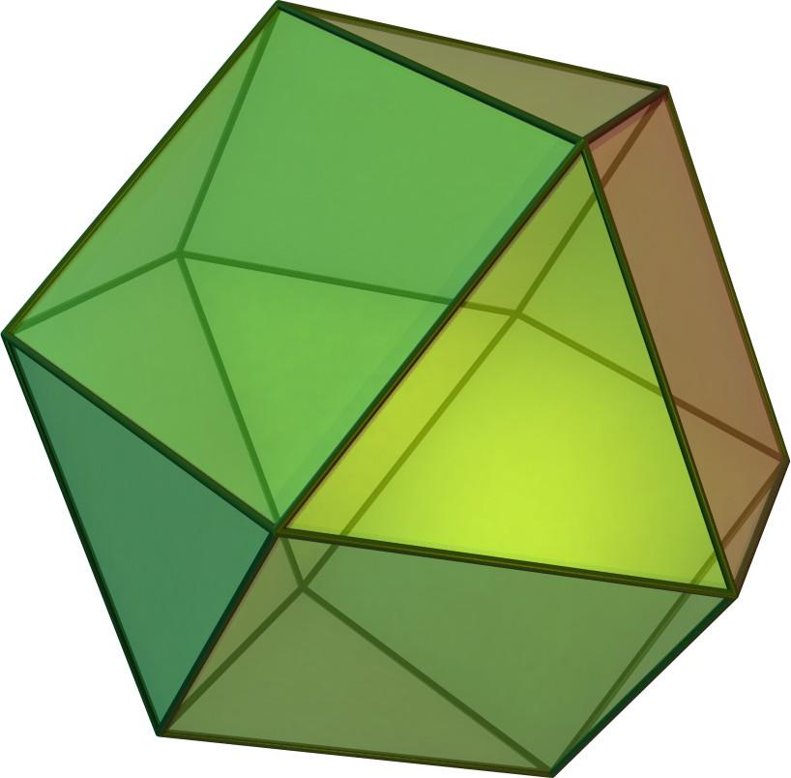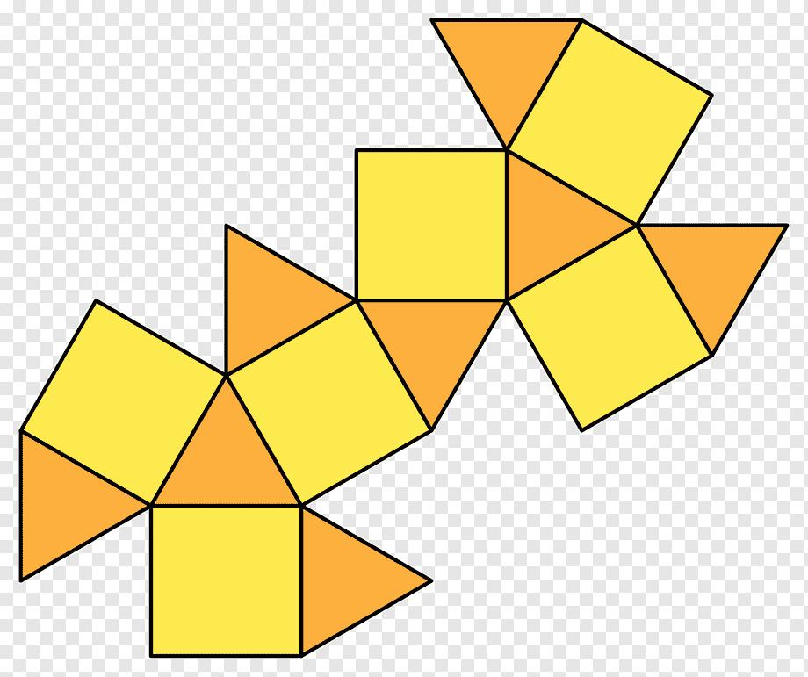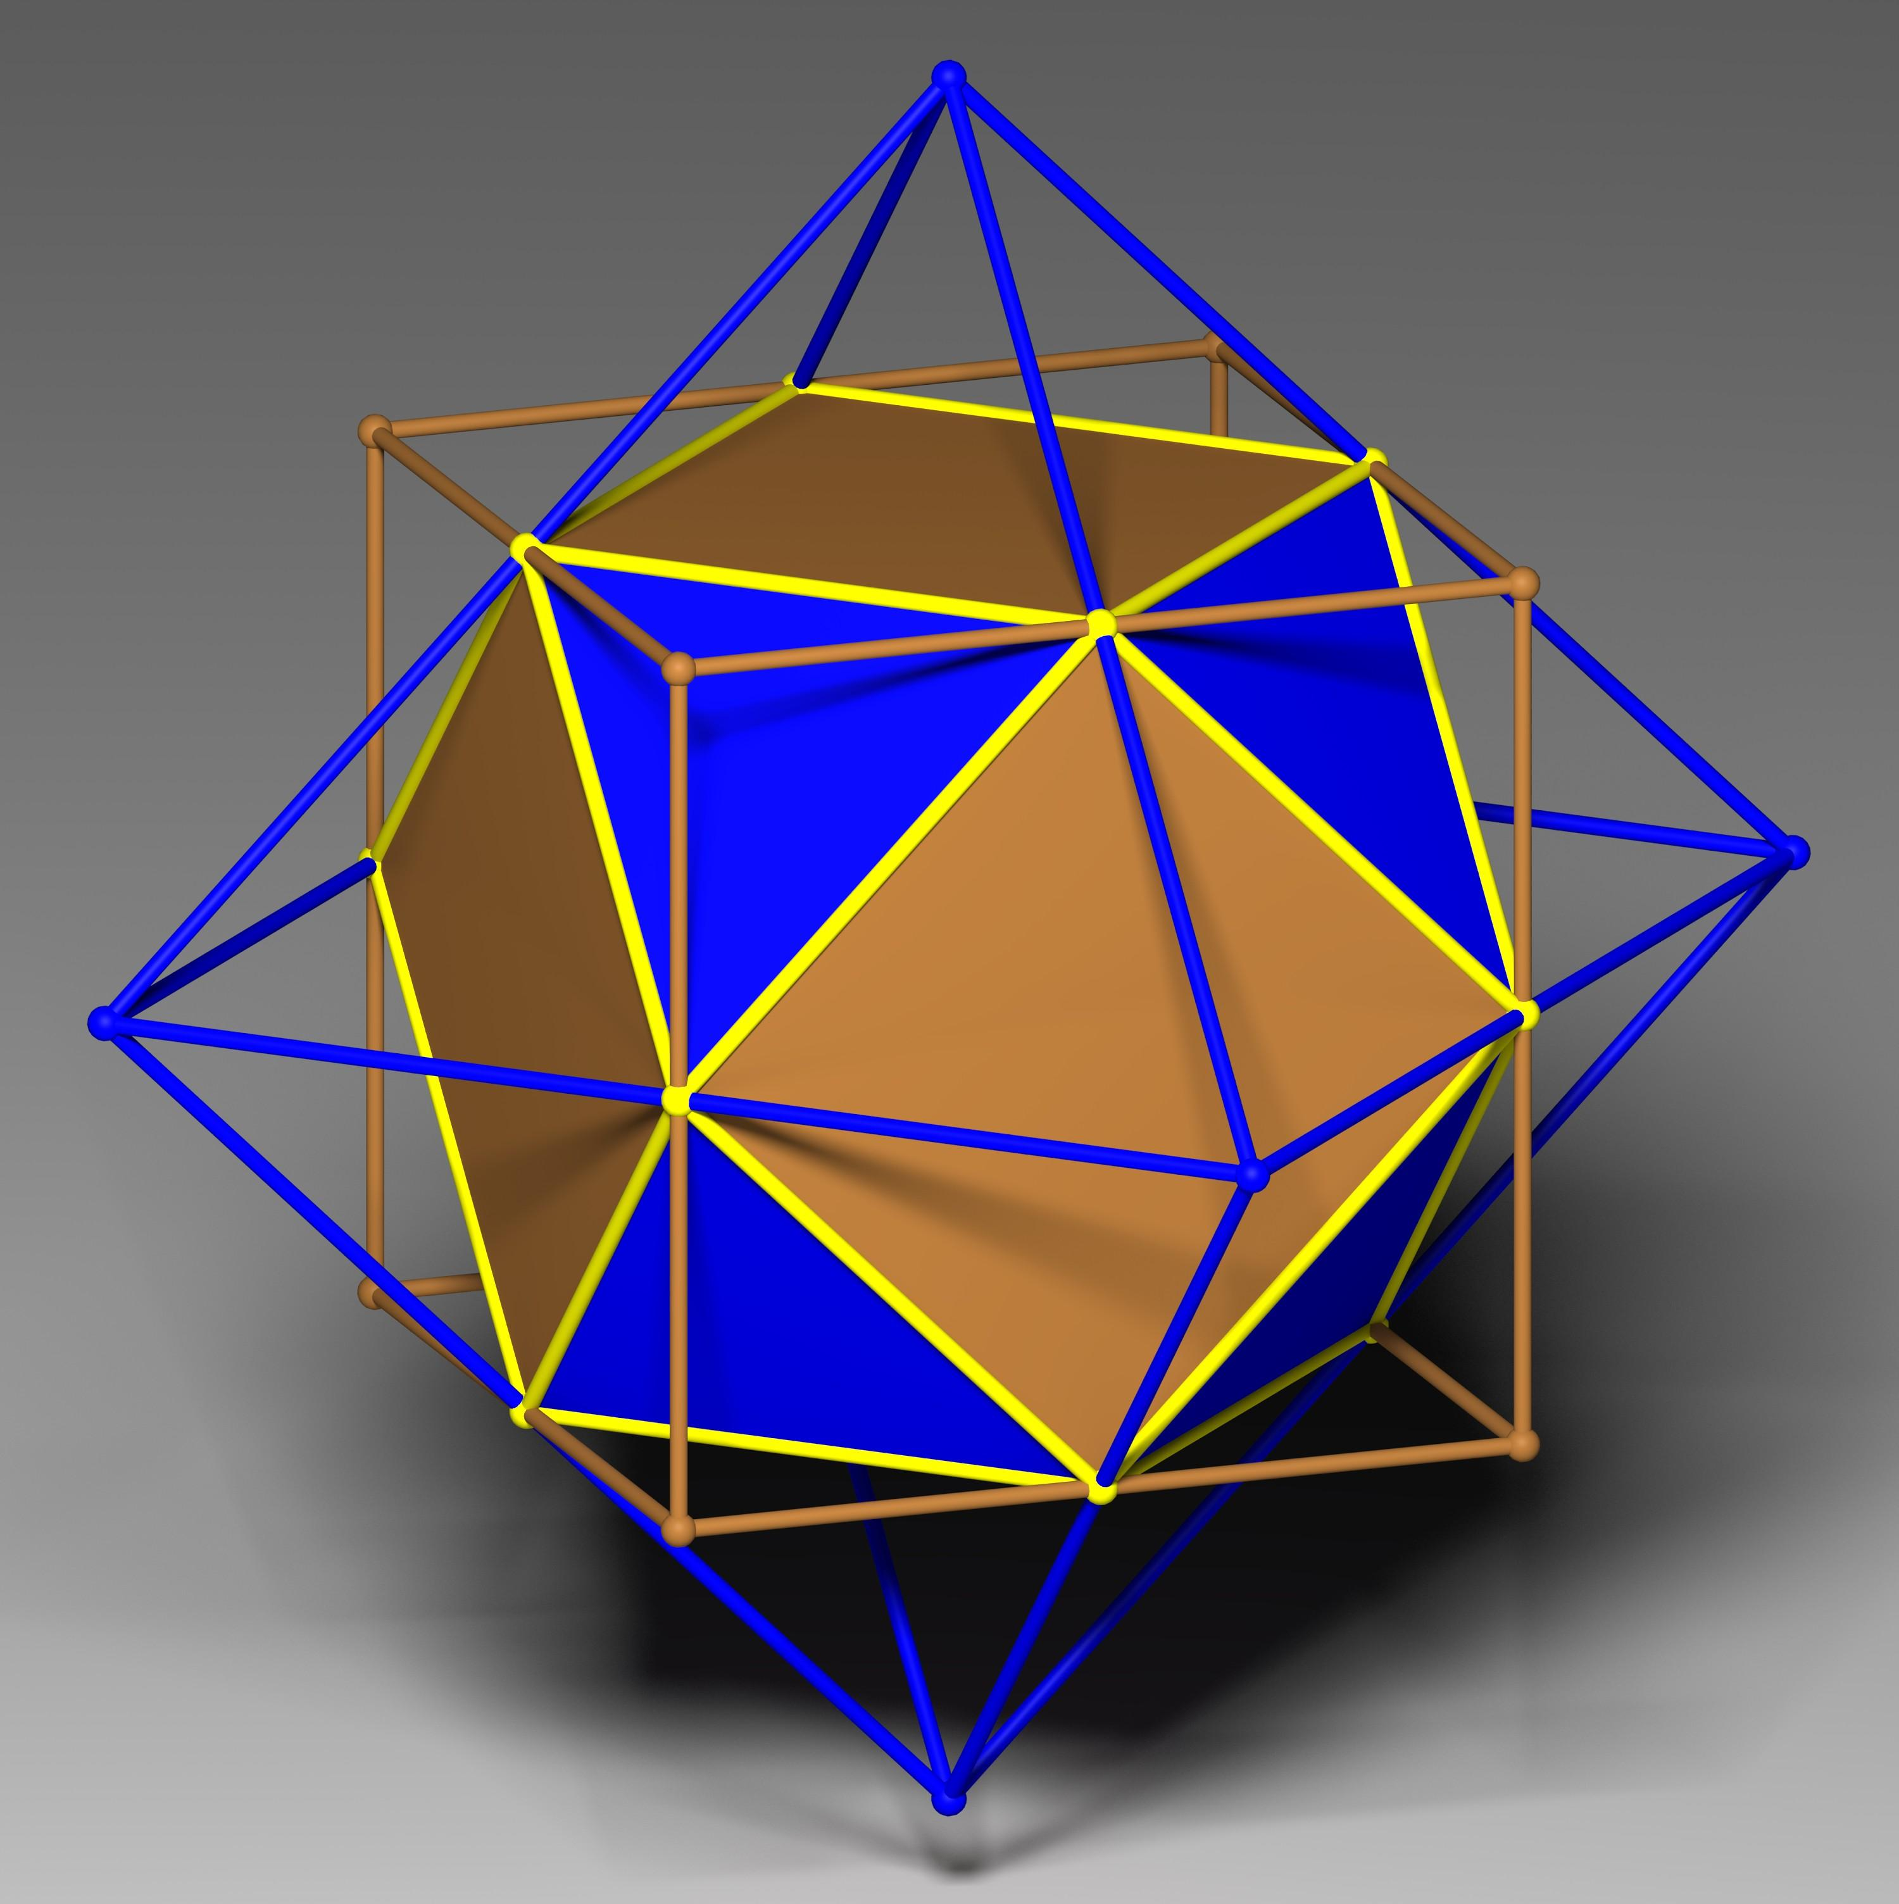

Mathematical Properties
# Source: AI Source: Provided by: [Data Path: Persons Table -> ID Column: 1, Name_En Column: Motasem Essam] -> From: [ChatGPT] on [7/25/2026]
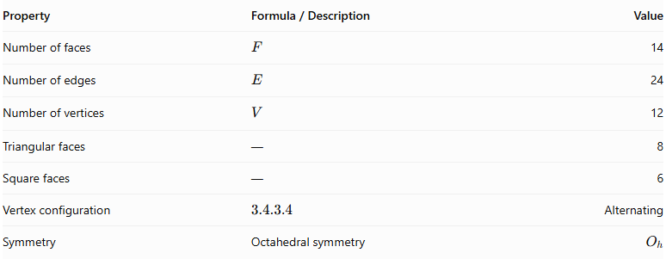
Property | Formula / Description | Value
Number of faces | $$F$$ | 14
Number of edges | $$E$$ | 24
Number of vertices | $$V$$ | 12
Triangular faces | — | 8
Square faces | — | 6
Vertex configuration | $$3.4.3.4$$ | Alternating
Symmetry | Octahedral symmetry | $$O_{h}$$
Vertex Configuration
$$3.4.3.4$$
This means that two equilateral triangles and two squares meet at every vertex, alternating around that vertex.
Euler's Polyhedron Formula:
$$V-E+F=2$$
$$12-24+14=2$$
The Cuboctahedron satisfies Euler's formula.

Geometric Characteristics
# Source: AI Source: Provided by: [Data Path: Persons Table -> ID Column: 1, Name_En Column: Motasem Essam] -> From: [ChatGPT] on [7/25/2026]
- Solid Type: Archimedean Solid.
- Face Shapes: Equilateral triangles and squares.
- Total Faces: 14.
- Total Edges: 24.
- Total Vertices: 12.
- Edge Lengths: All edges have equal length.
- Vertex Arrangement: Two triangles and two squares meet at every vertex.
- Symmetry: Octahedral symmetry ($O_{h}$).
- Convexity: Convex polyhedron.
- Dual Polyhedron: Rhombic Dodecahedron.
Surface Area and Volume
For an edge length $a$:
Surface Area:
$$A=6a^{2}+8(\frac{\sqrt{3}}{4}a^{2})$$
$$\boxed{A=2(3+\sqrt{3})a^{2}}$$
Volume:
$$\boxed{V=\frac{5\sqrt{2}}{3}a^{3}}$$

Geometric Construction
# Source: AI Source: Provided by: [Data Path: Persons Table -> ID Column: 1, Name_En Column: Motasem Essam] -> From: [ChatGPT] on [7/25/2026]
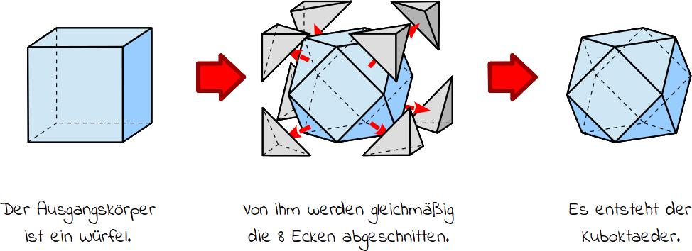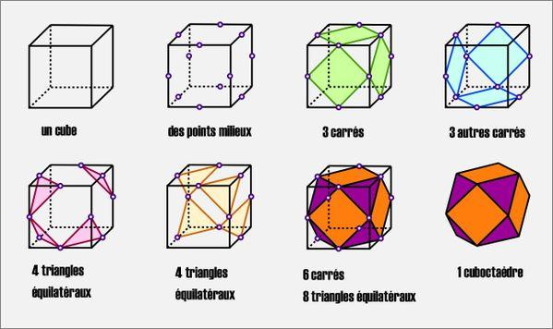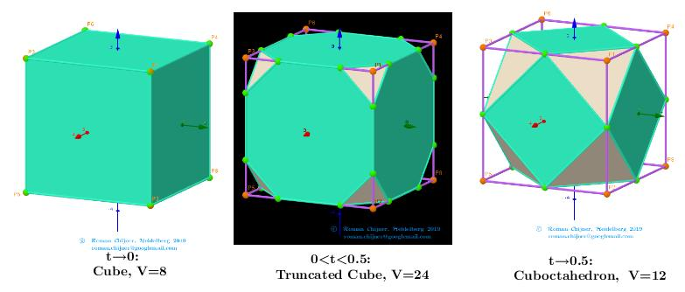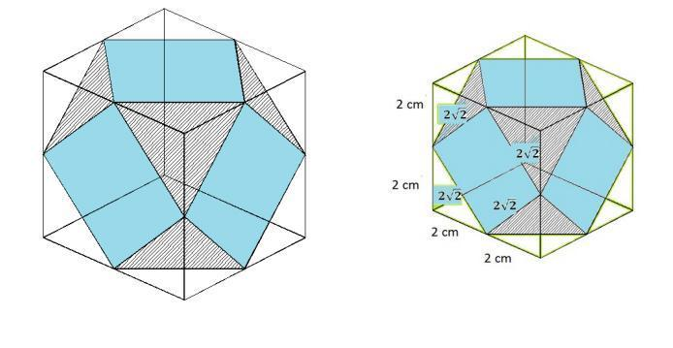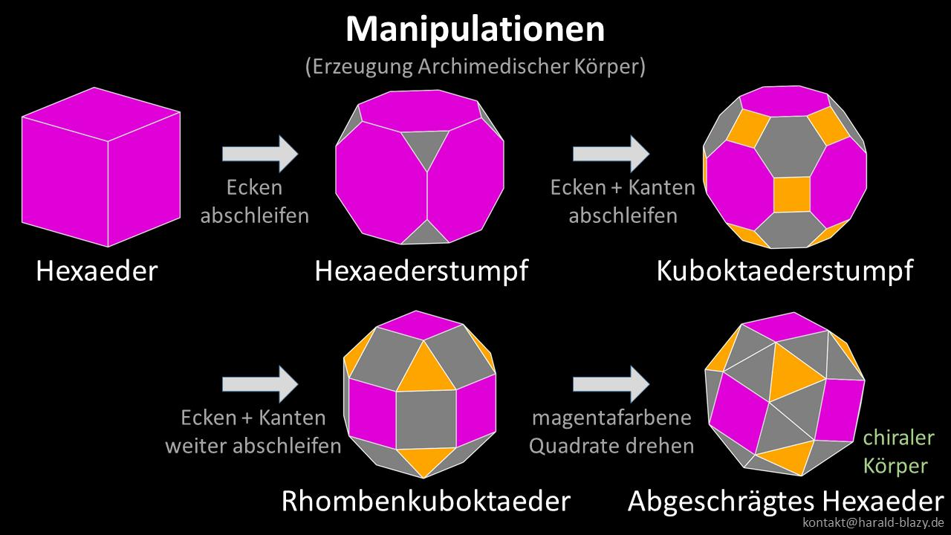
The Cuboctahedron can be constructed through Rectification, which involves:
- Starting with a cube or octahedron.
- Marking the midpoint of every edge.
- Connecting adjacent edge midpoints along each original face.
- Removing the original vertices and forming the resulting polyhedron.
The resulting solid contains 8 triangular faces and 6 square faces.

Related Geometric Solids
# Source: AI Source: Provided by: [Data Path: Persons Table -> ID Column: 1, Name_En Column: Motasem Essam] -> From: [ChatGPT] on [7/25/2026]
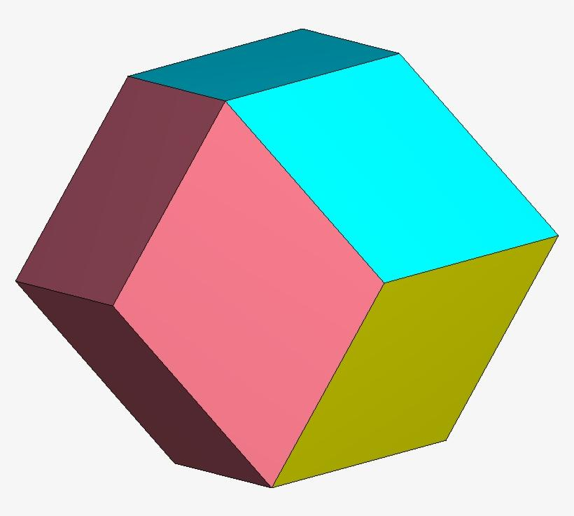
Rhombic Dodecahedron
The dual polyhedron of the Cuboctahedron, consisting of 12 rhombic faces.
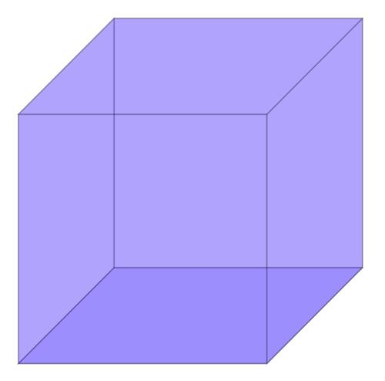
Cube
One of the two Platonic solids from which a Cuboctahedron can be obtained through rectification.
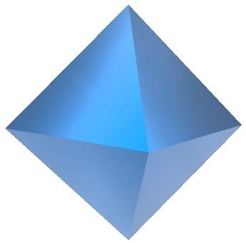
Octahedron
The other Platonic solid related to the Cuboctahedron through rectification.

Key Points
# Source: AI Source: Provided by: [Data Path: Persons Table -> ID Column: 1, Name_En Column: Motasem Essam] -> From: [ChatGPT] on [7/25/2026]
- The Cuboctahedron is one of the 13 classical Archimedean solids.
- It contains 8 equilateral triangular faces and 6 square faces.
- It has 14 faces, 24 edges, and 12 vertices.
- Its vertex configuration is $3.4.3.4$.
- It can be constructed by rectifying a cube or an octahedron.
- Its dual polyhedron is the Rhombic Dodecahedron.
- It is also called the Rectified Cube or Rectified Octahedron.

Main Classification
# Source: AI Source: Provided by: [Data Path: Persons Table -> ID Column: 1, Name_En Column: Motasem Essam] -> From: [ChatGPT] on [7/25/2026]
Solid Geometry
└── Types of Solids
└── Archimedean Solids
└── Types of Archimedean Solids
└── Cuboctahedron
├── Equilateral Triangular Faces
├── Square Faces
├── Vertices
├── Edges
└── Geometric Properties

Conclusion
# Source: AI Source: Provided by: [Data Path: Persons Table -> ID Column: 1, Name_En Column: Motasem Essam] -> From: [ChatGPT] on [7/25/2026]
The Cuboctahedron is a convex Archimedean solid consisting of 8 equilateral triangles and 6 squares. Its 12 vertices, 24 edges, and 14 faces form a highly symmetrical polyhedron. It is closely related to the cube and octahedron through rectification and has the Rhombic Dodecahedron as its dual.

